Screenshots

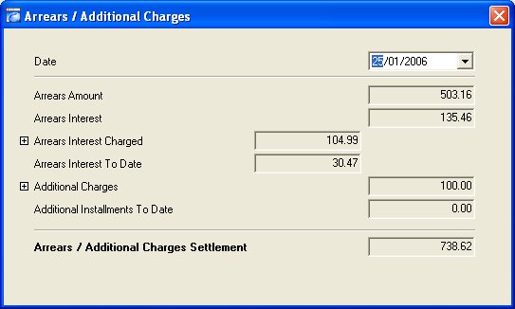
Figure 1 The Arrears Settlement Screen

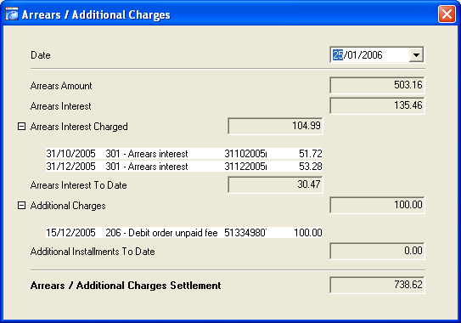
Figure 2 The Arrears Settlement Screen (Expanded)

Arrears Amount
This figure is based on pure arrears, i.e., the sum of transaction types 11 and 12 minus the sum of the instalments on the contract for a given date. If this amount is negative it means that the client has overpaid and this negative amount is carried to the “Additional Instalments to Date” field and the arrears amount becomes zero.

Arrears Interest
The sum of “Arrears Interest Charged” and “Arrears Interest To Date”.

Arrears Interest Charged
All arrears interest transactions (type 3) charged to the Client Account. This field can be expanded to see exactly what transactions make up this amount (see Figure 2).

Arrears Interest To Date
All additional arrears interest to date not yet calculated and posted to the Client Account.

This field is calculated as follows:
+ All Interest (4, 13, 14)
+ Interest to date (Interest accrued on a daily basis since the last monthly interest run)
- All Arrears (3)
- Arrears Bucket
- All Contract Interest to date

Additional Charges
All additional charges transactions posted to the account (type 2). This field can be expanded to see exactly what transactions make up this amount (see Figure 2).

Additional Instalments to Date
See “Arrears Amount”.

